PERSUASIVE ~ ENGAGING ~ INSPIRING ~ MOTIVATING ~ INTRIGUING ~ DYNAMIC ~PROFESSIONAL

Anita Agers Brooks: Head Copywriter ~ FreshFaith Inspirations Copywriting Services


Sample Freelance Copywriting Project Proposal

Prepared for: Adventures Unlimited, Inc.

Prepared by: Anita Agers Brooks, Head Copywriter for Fresh Start-Fresh Faith, LLC, d/b/a FreshFaith Inspirations

Copywriting

July 22, 2015

Proposal number: 123-4567
FRESHFAITH INSPIRATIONS COPYWRITING SERVICES ~ ANITA@ANITABROOKS.COM

EXECUTIVE SUMMARY

Overview

The following freelance contract is custom written according to the job and client. For more information about how I can benefit your business, please view my page at anitabrooks.com/freshfaith-inspirations-copywriting. For basic prices, see anitabrooks.com/copywriting-basic-fee-prices

Mission

Our mission is to increase your profits and drive your customer/client traffic in a more productive way.

Quest

Want more of the market share? It’s proven — words have the power to harm or to heal, what are your words doing to your business?

Benefits to Hiring Fresh Start-Fresh Faith, LLC, d/b/a FreshFaith Inspirations Copywriting

Written and/or reviewed by Anita Agers Brooks, who works passionately, eﬃciently, and productively in a strategic and tactical way. I LOVE copywriting! These are the unique qualifications I/we bring:

- Strong, Solid, Scintillating Writers

- Certified Personality Trainer

- Certified Communications Specialist

- Certified Leadership Training Facilitator

- Search Engine Optimization Expertise

- Customer Service Trainer

- Marketing Background w/Corps such as Nike, Enyce, Greg Norman Golf, Ozark Outdoors Riverfront Resort

- Successful Business Coach

- Published Creative Non-Fiction Author

- Vast Social Media/Publicity Experience

- Strategic and Tactical Creativity

- Proven Success with Existing Clients

- Integrity — Doing the Same Thing Whether Anyone Else Can See or Hear Us or Not

- Boring is NOT our Brand!
FRESHFAITH INSPIRATIONS COPYWRITING SERVICES ~ ANITA@ANITABROOKS.COM

BUDGET

Project Estimate as Scoped

With clear objectives, detailed concepts, communicated expectations, specific requests, and no significant changes to our initial agreement, we will efficiently and effectively write the following marketing content:
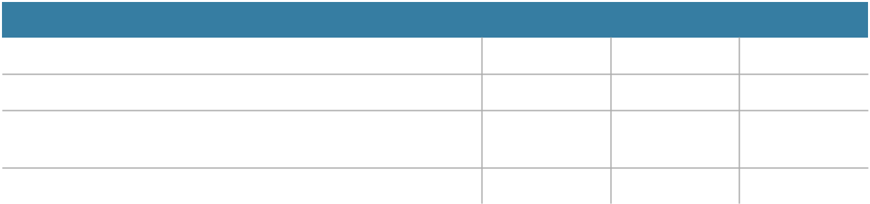

Description | Quantity | Unit Price | Cost
Per Word Fee: Query Letter to Potential Client | 250 | $ 1 | $ | 250
Per Hour Fee: Write Five Pages for Marketing Brochure | 10 | $ 75 | $ | 750
Per Web Page Fee: Create Unique SEO Rich Content for | 3 | $ 300 | $ | 900
Three Website Pages
**Payment due with 14 days of each Invoice Submission
Total |  |  | $ | 1,900
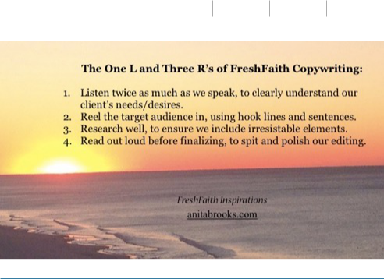
FRESHFAITH INSPIRATIONS COPYWRITING SERVICES ~ ANITA@ANITABROOKS.COM

CONTRACT

Parties and Assignment:

This agreement is made and entered into the ______ (day) of _____________,

2015 by (client company) ____________________________ having a place of

business at _______________________________(client business address) and

Anita Agers Brooks, representing Fresh Start-Fresh Faith, LLC, d/b/a FreshFaith Inspirations Copywriting, (hereafter referred to as “copywriter”). The contract is in regards to professional copywriting services to be performed on/for the following project (s):

_________________________________________________________

_________________________________________________________

Work:

Copywriter agrees to produce written materials and provide proofreading services at the request of the client for fees agreed upon in advance and deliver the work by an agreed upon deadline. Copywriter agrees that she will be the sole author of the work, which will be original work by copywriter, free of plagiarism. Copywriter agrees to use reasonable care to ensure that all facts and statements in the work are true and that the work does not infringe upon any copyright, right of privacy, proprietary right, right of publicity or any other right of a third party. Copywriter agrees that client has the right to edit the work in a time frame agreed upon in advance as it deems appropriate for publication, and that copywriter will cooperate with client in editing and otherwise reviewing the work prior to publication. Writer will cooperate with client if any complaints, claims or litigation should arise regarding the work.

Confidentiality:

Copywriter acknowledges that she may be furnished or may otherwise receive or have access to information which relates to the client’s past, present or future products, creative works, marketing strategies, pending projects and proposals and other proprietary information which gives the client an opportunity to acquire an advantage over its competitors. Copywriter agrees to preserve and protect the confidentiality of the proprietary information of the client and all physical forms thereof, whether disclosed to copywriter before this Agreement is signed or afterward. Copywriter shall be prohibited from discussing the client or the work with a representative of the press, media or third party without the client’s prior written approval.
FRESHFAITH INSPIRATIONS COPYWRITING SERVICES ~ ANITA@ANITABROOKS.COM

Compensation:

Client agrees to pay copywriter a consultation fee of $ _________per hour/project, and
work at a rate of $ _______per word/hour/page/project. Copywriter will bill client for
half of the total estimated cost upon completion of the first proof. Edits and revisions to the initial proof will not begin until payment for half the total estimated cost is received. Copywriter will submit the final invoice for the work after receiving approval of the second proof from client. The turnaround time for comments, edits and/or revisions is one week. If copywriter has not received any comments, revisions or edits within a week of submitting a completed final draft (2nd proof), copywriter will bill client for the remaining charges. Payment due within fourteen (14) days of invoice submission.

Copywriter requires a signed contract/initialized agreement before beginning Work. Incidental expenses (postage, courier service, etc.) are absorbed by copywriter. Mileage to special events or interviews is billed at the rate currently accepted by the IRS.

Payment and Collection:

Unless otherwise specified in writing, invoices not paid within thirty (30) days of the invoice date will accrue interest at 1.5% per month. Client agrees to pay via PayPal, for all deposits and services renderred. Client agrees that the purchase of the services described herein constitutes “doing business” in the State of Missouri and submits itself to the jurisdiction of the State of Missouri with respect to any suit brought by Fresh Start-Fresh Faith, LLC, d/b/a FreshFaith Inspirations Copywriting to collect any sums hereunder.

Client Approval:

Client is responsible for written approval of work ordered required for the completion of the work. This approval can be in the form of initials, electronic signature, or facsimile. Upon acceptance of the work, client accepts responsibility for any further processes in which this work is used. Copywriter is not responsible for errors occurring in this work or projects related to this work after acceptance of the work.

Changes:

Any verbal or written changes made by client to the scope of the work following its initiation by copywriter are subject to additional charges. Should such changes negate any part of the work already completed at the time of the changes, client accepts responsibility for payment of the completed work and all services related to it, in addition to charges for the changes.

Cancellation:

FRESHFAITH INSPIRATIONS COPYWRITING SERVICES ~ ANITA@ANITABROOKS.COM

Upon written or verbal cancellation, client is responsible for payment for all expenses incurred and any work done toward the completion of the project based on the percentage of project completed. Should Client cancel the project following its completion, client is responsible for full payment as per the above estimate plus all other expenses incurred.

I, ___________________________________ (Client company representative), assert
that I am a person employed by

___________________________________ (Client), and that I have the authority to
promise payment for the services rendered by FreshFaith Inspirations Copywriting for the aforementioned Work. I assert that I have read, understood and agree to the CopyWriting Contract and Agreement.

______________________________
Client Signature

_____________________
Date

I, Anita Agers Brooks, (copywriter) assert that I have read, understood and agree to the CopyWriting Contract and Agreement.

_______________________________
CopyWriter’s Signature

_____________________
Date

